Traeger Smoker Giveaway 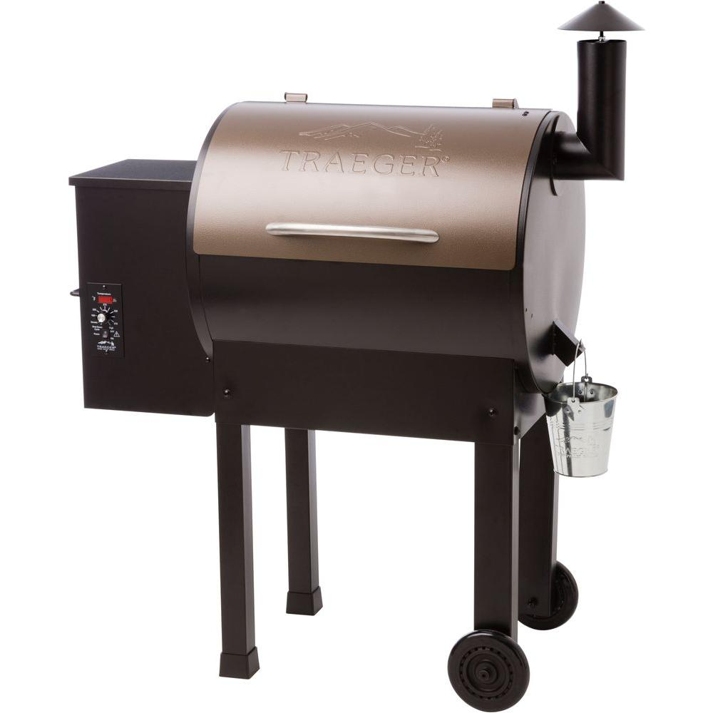
Like and/or comment on any of our Facebook pages after Nov. 1st and enter yourself into our giveaway for a Traeger Smoker.
Pretty simple right? Each week we will have a different video/blog talking about our approach to bbq and why we do things the way that we do it to give you the best possible bbq. We encourage you to respond and tell us what you think, ask questions, or share what you do at home. Each time you do, it enters you again in the contest.
We decided to giveaway a Traeger smoker because of its quality of build, ease of use and the quality of finished bbq it produces. We have used every type of smoker imaginable, anything from a traditional offset stick burner to a gravity fed pellet smoker, and we think this Traeger gives you the best of both worlds. Look out for our next blog when we go through the different types of smokers and the pluses and minuses of each.
Now for some of the contest rules:
How to Enter – this contest will be running on all of our Facebook pages (one for each of our 4 locations and 1 for the whole group) and if you like any of the pages from now until the drawing you will be entered in the contest.
Each time you comment on any of the posts from now until Dec. 14th you will also be entered to win for each comment. We encourage you to comment as much as you can and feel free to ask questions or even ask for suggestions for your Holiday dinners.
Who can participate – The only exclusions we will have will be staff members of Finley’s Grill & Smokehouse and their immediate family members. However, anyone can comment and/or like our page. Finley’s employees and immediate family will not be eligible to enter the contest.
Date and winner announcement – we will hold a live drawing on Dec. 14th where we will draw the winner live on Facebook. After the video we will contact the winner via Facebook Messenger.
This contest is not sponsored, endorsed, administered by Facebook and all entrants must release Facebook from any and all liability when entering this contest.

